1. Create a file friends.txt with a list of names of three of your friends on separate lines.

-To create a .txt file we can use an editor like **vim** or **nano** to create the file and enter the names in separate lines.

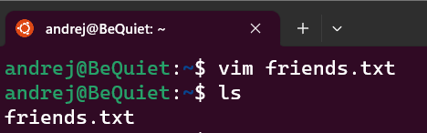

2. Display the contents of friends.txt on the console.

-To display the contents of a text file we can use the command **cat**

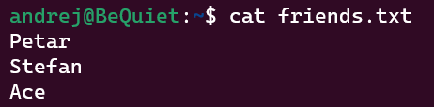

3. Rename file friends.txt to bestfriends.txt

-To rename a file we can use the command **mv ‘file name’ ‘new name’**

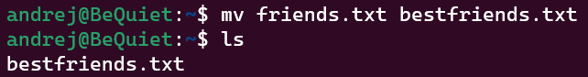

4. Make a copy of bestfriends.txt under the name sysadmins.txt

-To copy a file we use the command **cp**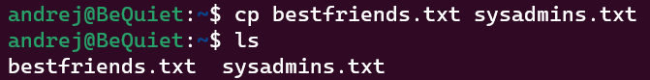

5. List all files whose name begins with letter 'b' and ends with extension txt.

-To list all files that begin with letter ‘b’ and have extension txt we use **ls b*.txt**



6. Write a command that will tell you how many bytes are taken up by file sysadmins.txt

-To get the size of a file we can use the command **ls -sh ‘name of file’**



-To get the size of a file in bytes we can use the command **wc – c ‘name of file’**



7. Create file cars.txt with a list of 5 brands of cars on separate lines.

-We create the file using **vim**



8. Check how many bytes are taken up by the file.



9. Copy the file cars.txt into directory /tmp

-We copy the file using the command **cp**



10. List all files with extension *.txt in directory /tmp and verify that the file was copied properly.

-To list all the files with the extension *.txt in the /tmp directory we can use the command **find /tmp -name “*.txt”** or **ls /tmp/*.txt**





11. Without leaving your home directory rename file cars.txt located in /tmp to vehicles.txt in /tmp

-To rename a file we can use the command **mv path/’filename’ path/’newname’**



12. Display the contents of /etc/passwd file on the screen interactively (so you can search, scroll up and down)

-To display the contents of a file we can use editors like **nano, vim, less etc.** 